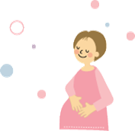Welcome Baby Project Mitaka

**We support giving birth and childcare!**

**Notice of“Yurikago Counseling”**

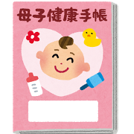Mitaka City has introduced "Welcome Baby Project Mitaka" to support giving birth and childcare in our area. We provide "Yurikago Counseling" with a public health nurse based on the Pregnancy Notification Form so that pregnant women can get advice and information on valuable services during pregnancy and after giving birth.

Participants can get a childcare support gift card (value: 10,000 Yen of KID's GIFT CARD).

（＊"Welcome Baby Project Mitaka" is a project for providing constant support during pregnancy and after giving birth.）

**１．How to receive counseling**

Counseling is offered only on an appointment basis (Weekdays 9:00-16:00).

Please make a reservation in advance via telephone.

Location： (see the map below)

Reception hours：Weekdays 9:00-17:00

Telephone Number： 0422-46-3254



**２．****What we talk about**

＊How to spend time during pregnancy, preparation for giving birth

＊Information on services for pregnant women and after giving birth

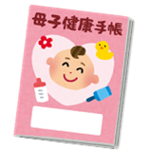＊Your psychological and physical condition

**３．The hours for interviews**

＊30 minutes to 1 hour per person

**４．What to bring**

保健師

　＊Mother and child handbook

　＊Health bag for mother and child (distributed when you hand in your

Pregnancy Notification Form)

**【Map to the Comprehensive Health Center】**

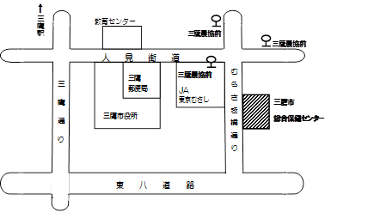

Contact : Mitaka City Comprehensive Health Center (Health Promotion Div.)

Address : Mitaka-shi Shinkawa 6-35-28

Tel.　0422-46-3254

We support you giving birthin a safe environment.